Ambulance Maintenance Form

Name of Reporting Employee: _____________________________________________________

Date of Report: _____________________ Incident or Patient Card # if applicable: ___________

Vehicle #: __________ Mileage: ______________ License Tag #: ________________________

The following space should be used to describe the problem/issue to be serviced: ____________________________________________________________________________________________________________________________________________________________________________________________________________________________________________________________________________________________________________________________________________________________________________________________________________________________________________________________________________________________________________________________________________________________________________________________________________________________________________________________________________________________________________________________________________________________________________________________________________
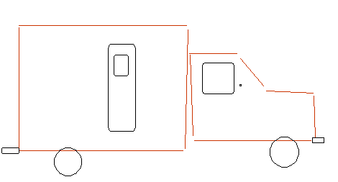
Clearly indicate locations on the diagram to assist in description.

